**Assignment #4. Responsive Web Design (Media Queries + Bootstrap Grid)**

**Student**: Urazbekova Amina

**Group**: MT-2406

**Part 1. Media Queries**

**Task 0. Responsive Typography**

In this task, I created a simple webpage that has a heading and just two paragraphs where I wrote what this page is supposed to show. I used CSS media queries to make the text responsive for different screen sizes. The font size becomes smaller on mobile devices, medium on tablets, and larger on desktop screens. This made the content easy to read on any device that you can use.

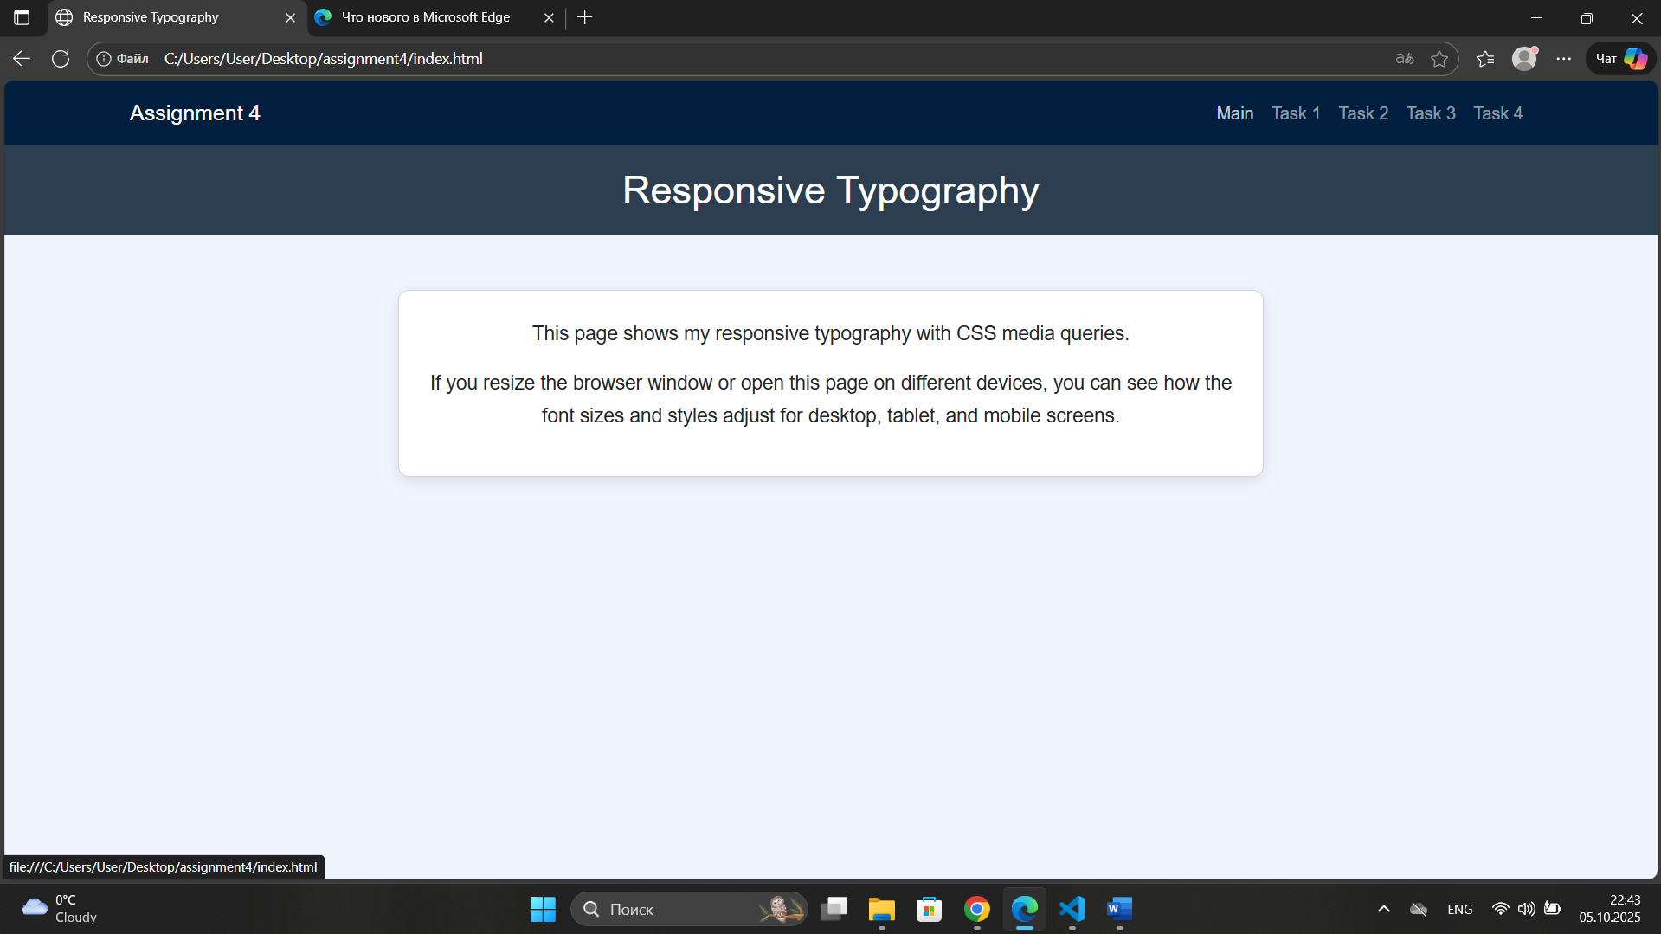

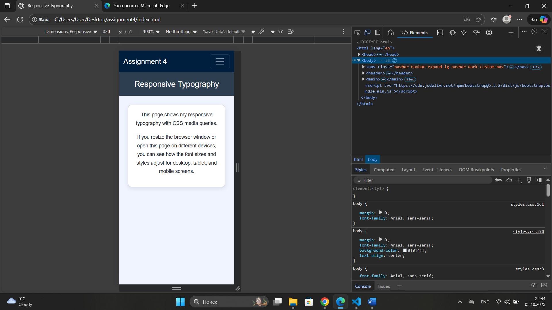

#### ****Task 1. Responsive Layout with Media Queries****

For this task, I designed a page with three boxes. Using only CSS media queries, I made them display side by side on desktop screens, two in a row on tablets, and stacked vertically on mobile devices. This shows how layouts can adapt automatically without using any frameworks.

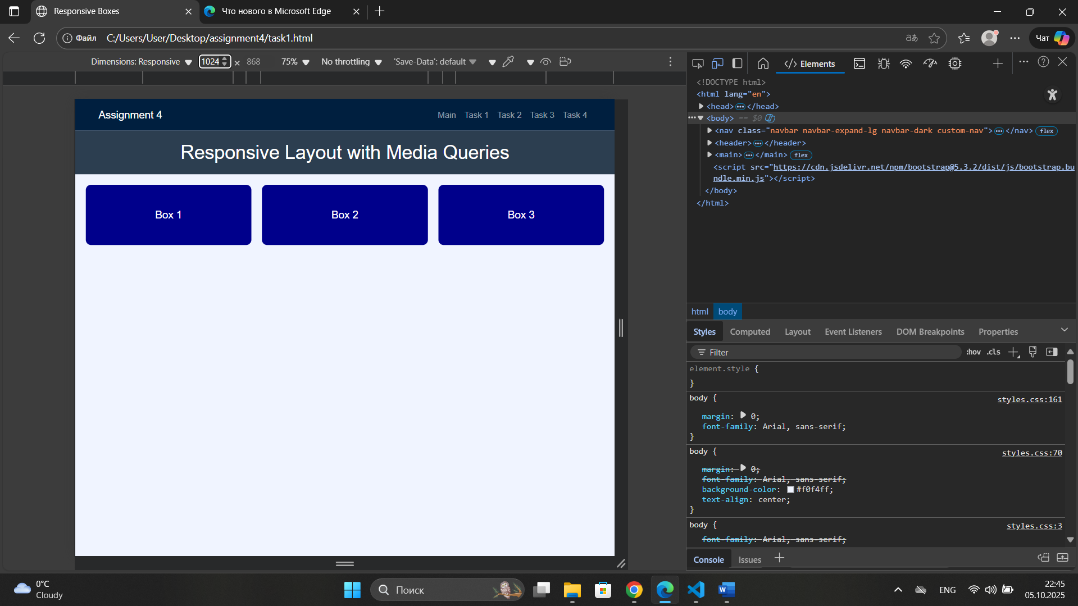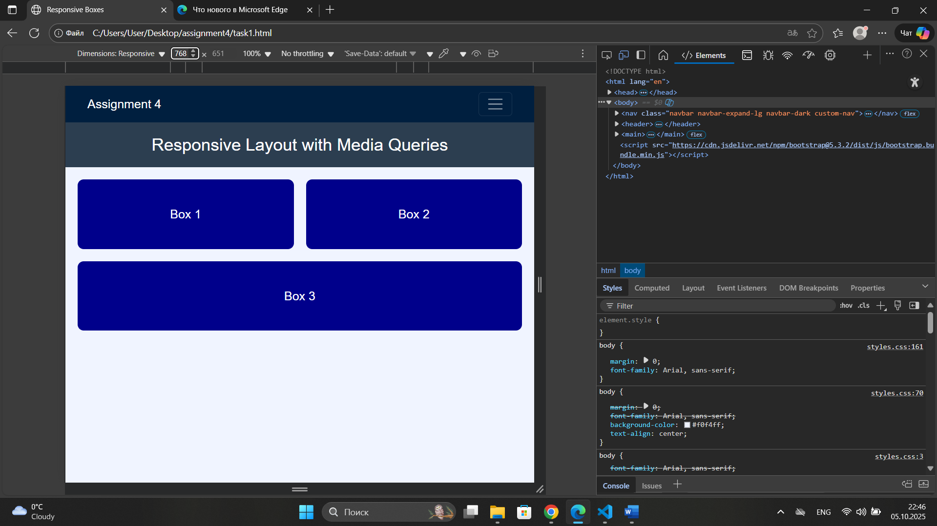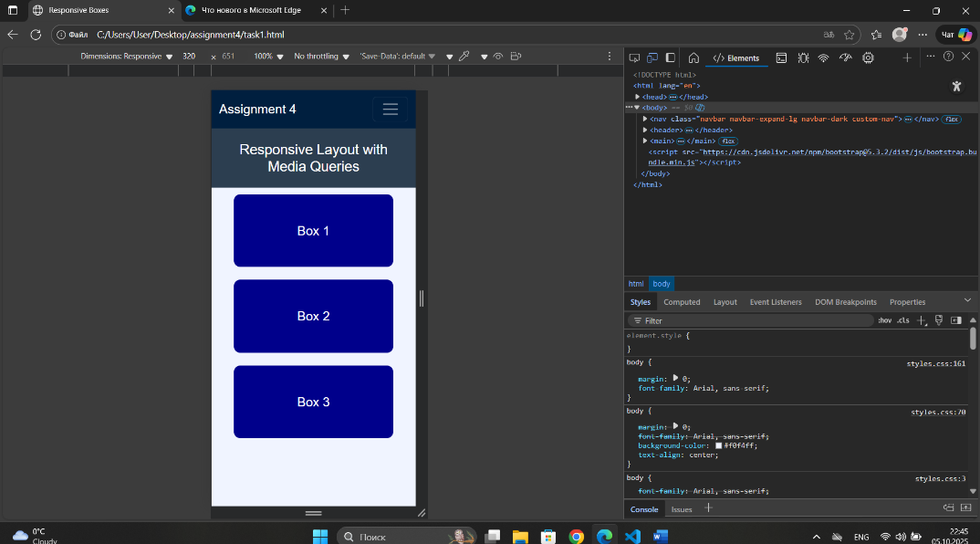

**Part 2. Bootstrap Grid System**

#### ****Task 2. Bootstrap Responsive Columns****

Here, I used Bootstrap’s 12-column grid system to create a responsive layout with three columns. These columns adjusted based on screen size, so each column took four columns by making three equal parts on desktop, two on the first row and one on the second on tablets, and all stacked on mobile devices. This task helped me understand how Bootstrap’s grid males it easier to create a responsive design like this.

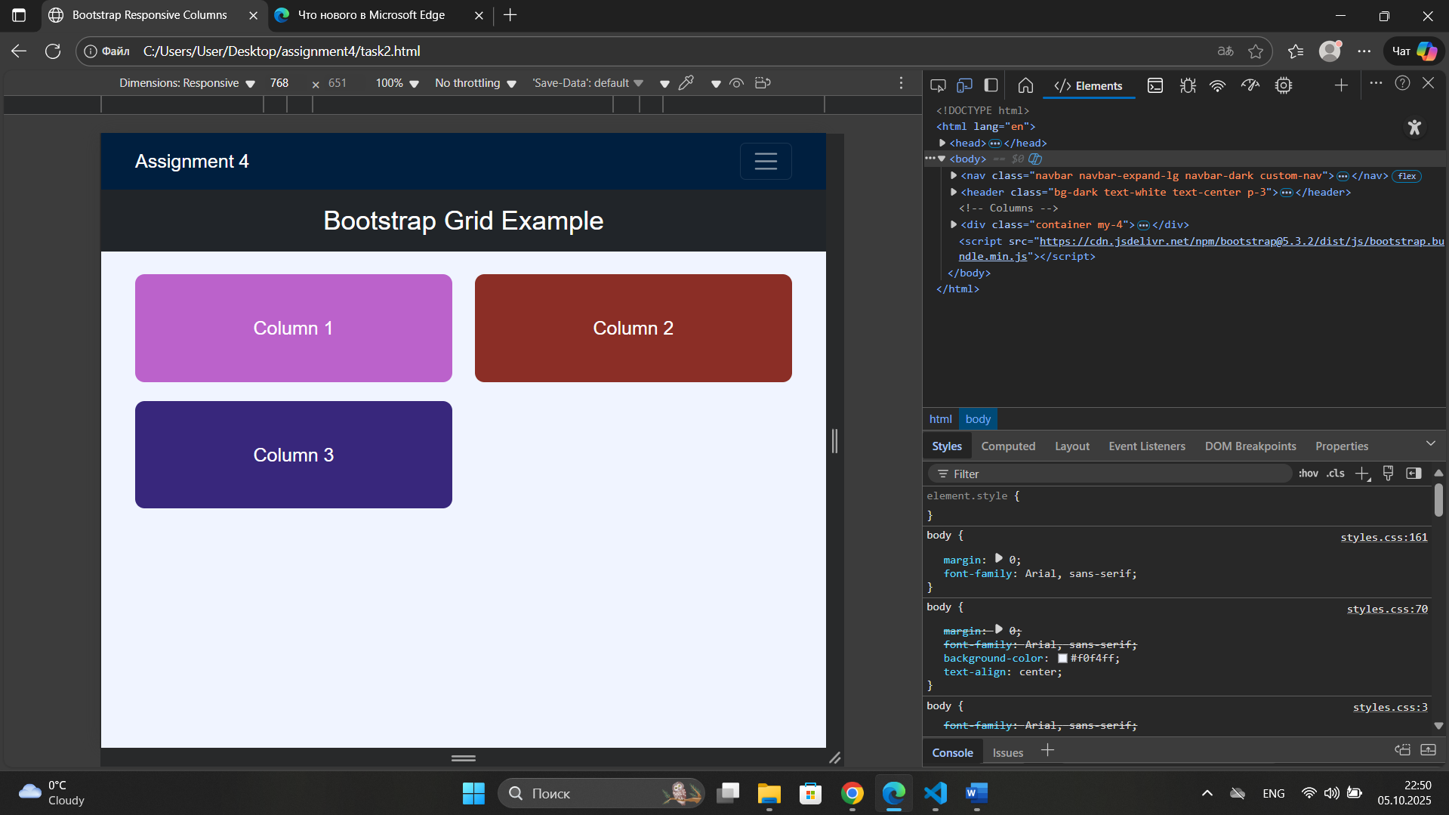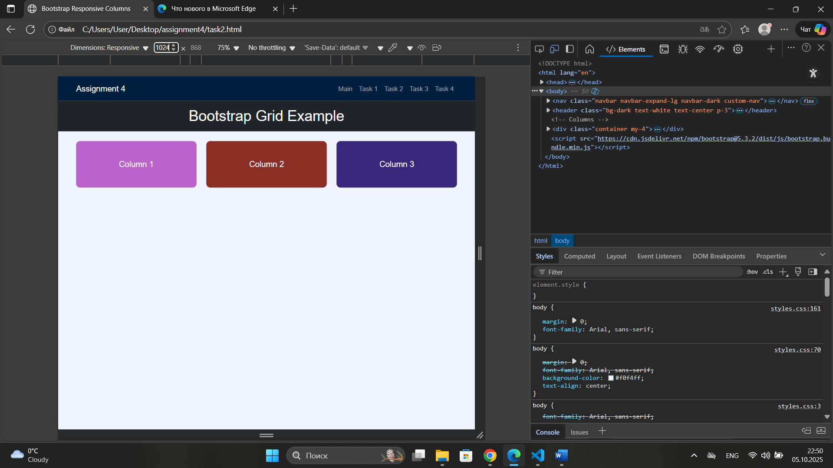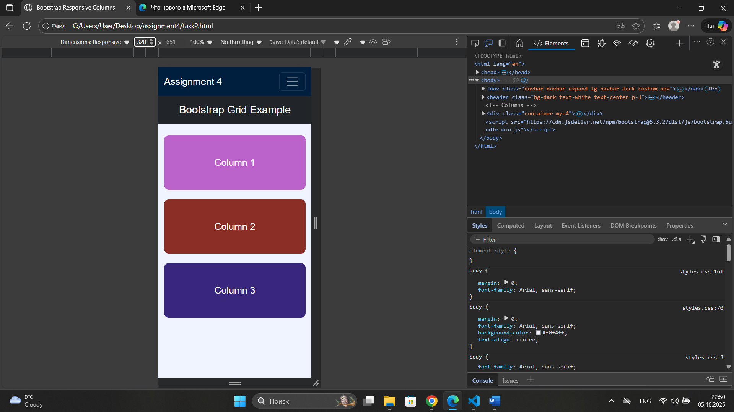

#### ****Task 3. Bootstrap Navigation Bar****

For this task, I created a responsive navigation bar using Bootstrap components. The navbar has a logo on the left and navigation links on the right. On smaller screens, like mobile devices and tablets, it collapses into a hamburger menu.

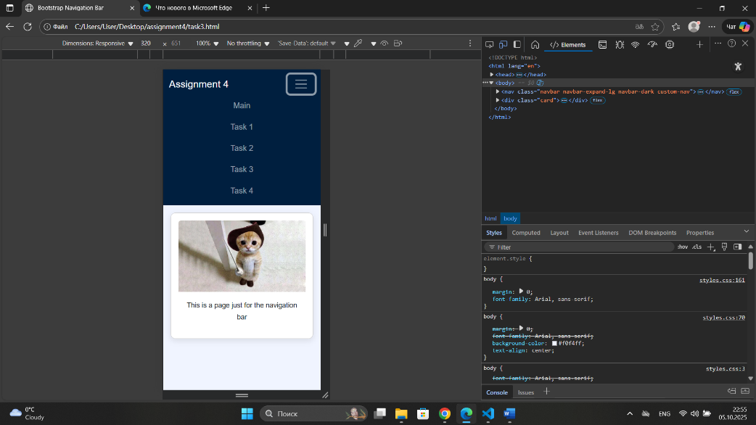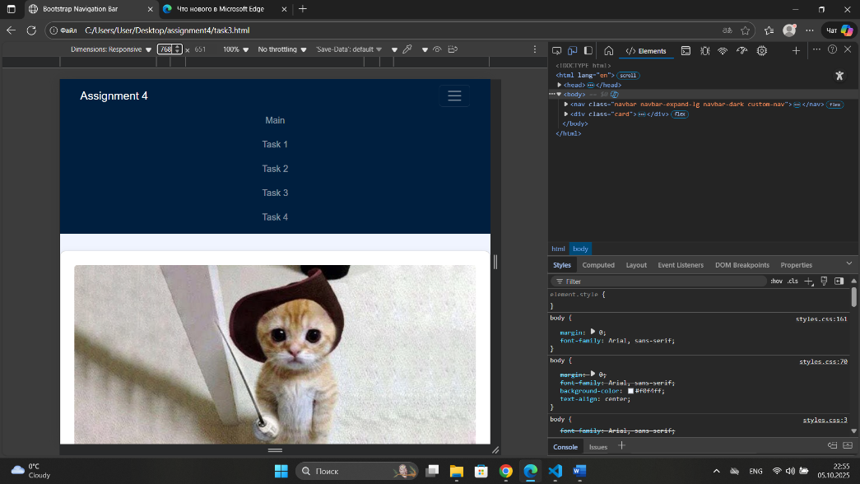

**Part 3. Combined Project**

#### ****Task 4. Responsive Portfolio Page****

Finally, here I built a complete responsive portfolio page using both CSS media queries and Bootstrap grid. This page includes a header with a Bootstrap navbar, a main section divided into two parts, with portfolio projects on the left side and personal information with contact details on the right side, and a footer at the bottom. I also used custom media queries to adjust font sizes, spacing, and visibility for different screen sizes.

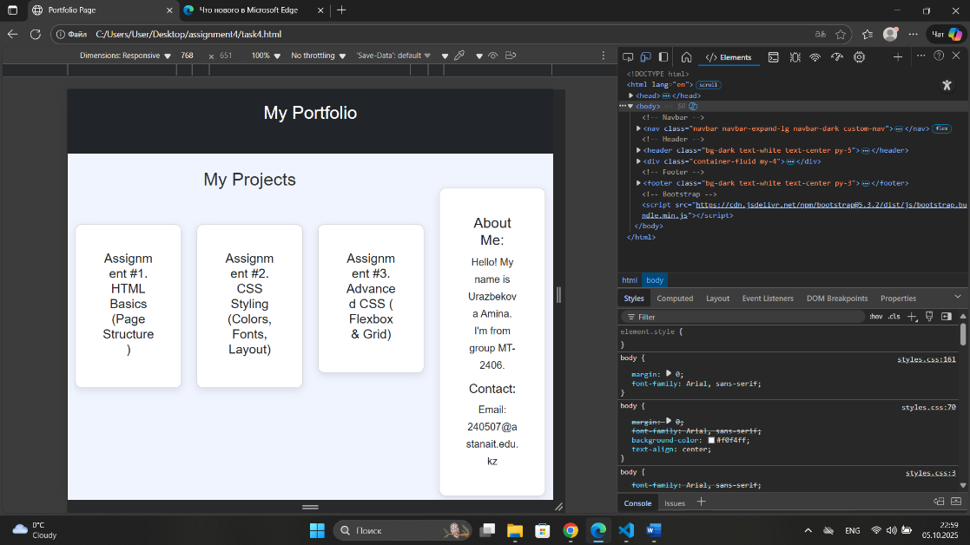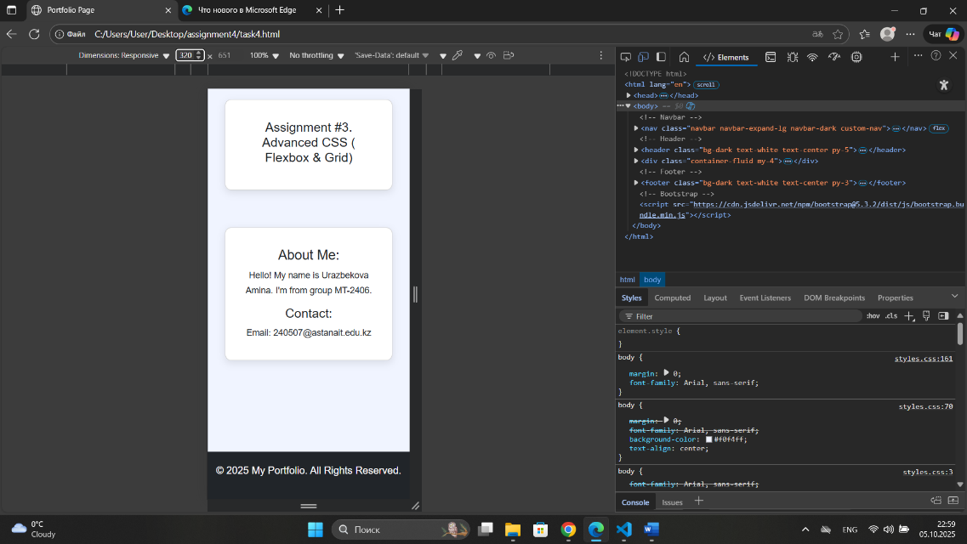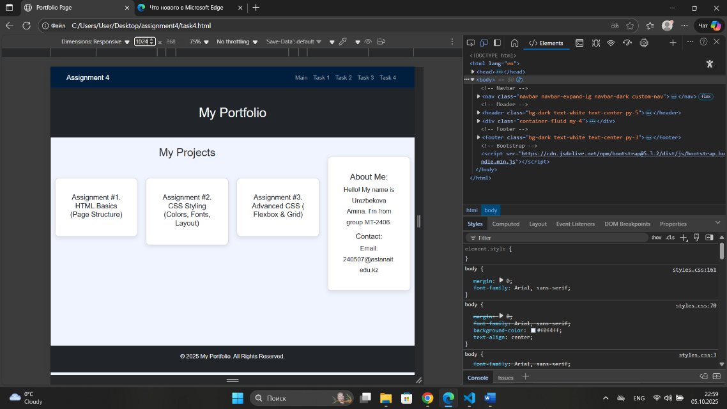

**Summary of My Work Process**

Throughout this assignment, I learned how to make web pages responsive by using both CSS media queries and Bootstrap. I first practiced controlling element sizes and layout changes with CSS only, and then switched to using the Bootstrap grid system for faster and structured design. Then, I combined both methods in the portfolio project, and made sure that every part of the page looked good on all screen sizes, from desktop, to tablets and simple mobile devices. I also checked that my project ran without any errors and followed a clean, readable code structure.